Transitioning Back to School
Take Care of Self
Reflect
COVID-19 has disrupted our lives and changed what was normal for us, all of us, around the world. We must take the time to reflect on ourselves – what changes have occurred for us and our families since March 2020 and how we are dealing with those changes.

How has life changed for you since March 2020?

How have you been coping with those changes?

Are you ready to start the new school year?

We must acknowledge our struggles and our difficulties and be grounded in ourselves and our reality. If we do this, we will be better able to work efficiently and effectively.

Take Care of Self
Reflect
Let’s make a timeline.

Write your current age in the box below.

0

On your timeline. Make note of how old you were when you started working in your current profession (i.e. teacher, principal, counsellor, etc.)

Why did you choose your profession? What influenced your choice? Reflect on your life from as early as you can remember to the age that you started working in your current profession.

How long have you been working in your current profession? Why have you stayed in the profession?

Atkins, R., 2018. Find Your Why. [Blog] Counselor Up!. Available at:
<https://www.counselorup.com/blog/find-your-why> [Accessed 3 May 2021].
Take Care of Self
Reflect
Think about the best days you’ve had at work. What made those days so great?

Based on what you’ve written, complete the sentence below.

My job is meaningful to me because _______________________________

_____________________________________________________________

_____________________________________________________________

_____________________________________________________________

_____________________________________________________________

Having a sense of purpose can sustain and inspire you when things are going well and act as a powerful source of motivation to keep going when you encounter obstacles or difficulties or when you experience stress. Knowing your why will help you to inspire change in your community.

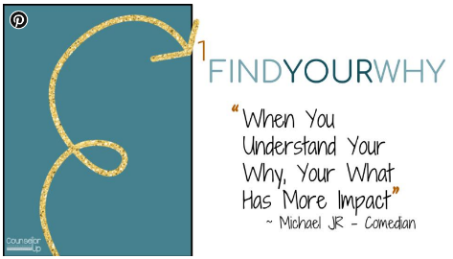

Atkins, R., 2021. Marketing Your School Counseling Program. [Blog] Counselor Up!, Available at:
<https://www.counselorup.com/blog/marketing-your-school-counseling-program> [Accessed 3 May 2021].
Happy Teachers Happy Schools, 2019. What's your why?. Available at:
<https://www.happyteachershappyschools.com/whats-your-why/> [Accessed 3 May 2021].
Take Care of Self
Reflect
Let’s dig deeper and reflect on your Life Philosophy. This is an opportunity to look inside yourself and identify your “assumptive world”.

Your assumptive world is like a camera lens containing your ideas, beliefs, and values through which you perceive the world around you. Your personal and motivating beliefs are core to your every action. The way you see the world is not just core to what you do but also ultimately the center of who you are.

Your life philosophy is your own, but it is made of many influences including your family, religion, ethnicity, gender, and socioeconomic status. Some questions to consider include the following:

- What do you value?

- What do you find meaningful?

- What keeps you going?

- What gives you inspiration?

- Why do you get up each day?

- What influences in your life have been most profound in shaping your life philosophy?

- What is your view of people? Are people essentially good, bad, or
neutral?

- How do we gain knowledge?

- What causes behaviour?

- Is spirituality important?

- What is right?

Halbur, D. and Halbur, K., 2011. Developing your theoretical orientation in counseling and psychotherapy. 2nd ed.
Boston: Pearson, pp.13-14.
Take Care of Self
Assess
If you had to describe yourself with one of the four words below which would you choose? Write the number 1 below that picture.

Rank the remaining three words in order from most like you (2) to least like you (4).

Visit https://personalitylingo.com/personality-test/ and take the free personality test to see if you get the same ranking as above.

Looking at personality types, whichever system you choose to use, can increase your understanding of yourself and others.

People have different preferences, communication styles, and ways of behaving and we often judge the world by what we would do in a certain situation.

We have been shaped, formed, and sculpted practically since the day we were born. Specific habits or manners can be conditioned into us to a certain extent. When we get around people we are fully comfortable with and we let our guard down or in times of stress when it can be difficult to concentrate, we have a tendency to “let our True Colours show”. Our conditioned behavior gives way to what comes more naturally.

If we understand ourselves and others, we can bring out the best in each other. Personality tests give us a common language.

Miscisin, M., Haines, J. and Lowry, D., n.d. Showing Our True Colors.
Take Care of Self
Assess
Let’s take a look at how you are currently using your time.

The circle below represents your life. Write your name in the smaller circle.

Think of your life as a pie. This pie encompasses all of your time. If you had to divide this pie into slices based on how you use your time what would it look like?

Divide the circle into slices and label them to show the various activities that you are engaged in on a regular basis. Some of the “pie slices” many people include are work, learning, family and other relationships, contributions to others, fun and leisure, physical and emotional self-care, and spiritual well-being.
Reflect on your current life by considering the following questions:

- Am I living a balanced life?

- Are my priorities and values reflected in this allocation of time?

- If I had one month left to live, is this the way I would allocate my time?

- Am I involved in too many activities?

- How much of my time is spent caring for others? For myself?

- Are there areas of my life that need my attention?

- Is there a dream or desire that keeps getting put on the back burner that I’d like to focus on now?

- What needs less attention?

- What needs more attention?

- What changes do I want to make?

“Harmony is more achievable than balance. You can’t have every aspect of your life divided into equal parts (balance). With harmony, things ebb and flow together.” ~Nedra Tawwab
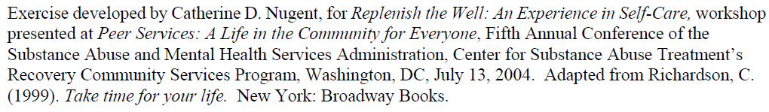
Take Care of Self
Assess
Take some time to assess how well you take care of yourself. This assessment tool provides an overview of effective strategies to maintain self-care. After completing the full assessment, choose one item from each area that you will actively work to improve.

Using the scale below, rate the following areas in terms of frequency.
3 - I do this well (frequently) 0 – I never do this
2 - I do this OK (occasionally) ? - This never occurred to me
1 - I barely or rarely do this

Physical Self-Care
___ Eat regularly (e.g., breakfast, lunch, and dinner)
___ Eat healthy
___ Exercise
___ Get regular medical care for prevention
___ Get medical care when needed
___ Take time off when needed
___ Get massages
___ Dance, swim, walk, run, play sports, sing, or do some other physical
activity that you find fun
___ Take time to be sexual—with yourself, with a partner
___ Get enough sleep
___ Wear clothes you like
___ Take vacations
___ Take day trips or mini-vacations
___ Make time away from telephones
___ Other:

Psychological Self-Care
___ Make time for self-reflection
___ Have your own personal psychotherapy
___ Write in a journal
___ Read literature that is unrelated to work
___ Do something that you are not an expert at or in charge of
___ Decrease stress in your life
___ Let others know different aspects of you
___ Notice your inner experience—listen to your thoughts, judgments,
beliefs, attitudes, and feelings
___ Engage your intelligence in a new area, e.g., go to a museum, exhibit,
sports event, performance
___ Practice receiving from others
___ Be curious
___ Say “no” to extra responsibilities sometimes
___ Other:

Emotional Self-Care
___ Spend time with others whose company you enjoy
___ Stay in contact with important people in your life
___ Give yourself affirmations, praise yourself
___ Love yourself
___ Re-read favorite books, re-view favorite movies
___ Identify comforting activities, objects, people, relationships, places
and seek them out
___ Allow yourself to cry
___ Find things that make you laugh
___ Express your outrage in social action, letters and donations, marches,
protests, etc.
___ Play with children
___ Other:

Spiritual Self-Care
___ Make time for reflection
___ Spend time with nature
___ Find a spiritual connection or community
___ Be open to inspiration
___ Cherish your optimism and hope
___ Be aware of nonmaterial aspects of life
___ Try at times not to be in charge or the expert
___ Be open to not knowing
___ Identify what is meaningful to you and notice its place in your life
___ Meditate
___ Pray
___ Sing
___ Spend time with children
___ Have experiences of awe
___ Contribute to causes in which you believe
___ Read inspirational literature (talks, music, etc.)
___ Other:

Workplace or Professional Self-Care
___ Take a break during the workday (e.g. lunch)
___ Take time to chat with co-workers
___ Make quiet time to complete tasks
___ Identify projects or tasks that are exciting and rewarding
___ Set limits with your students and colleagues
___ Balance your caseload so that no one day or part of a day is “too
much”
___ Arrange your workspace so it is comfortable and comforting
___ Get regular supervision or consultation
___ Negotiate for your needs (benefits, pay raise)
___ Have a peer support group
___ Other:

Balance
___ Strive for balance within your work-life and workday
___ Strive for balance among work, family, relationships, play and rest

Source: Transforming the Pain: A Workbook on Vicarious Traumatization. Saakvitne, Pearlman & Staff of TSI/CAAP (Norton, 1996)
Take Care of Self
Assess
How do you stress?

We all experience stress differently. If you understand what stress looks like for you then you can implement healthy strategies to deal with your stress.

Identify your stressors – What causes you to be stressed?

Learn to recognize stress signals – What are your internal bells?

- difficulty sleeping
- weight gain
- stomach pain
- teeth grinding
- panic attacks
- headaches
- difficulty concentrating
- sweaty hands or feet
- ______________________
- ______________________
- m

- heartburn
- excessive sleeping
- social isolation
- fatigue
- nausea
- feeling overwhelmed
- obsessive or compulsive behaviours
- weight loss
- _____________________________
- _____________________________

Recognize your stress strategies – What is your go-to tactic for calming down?

- Deep breathing
- Stretching
- Meditation
- Listening to music
- Exercising
- Reading
- Going for a walk
- Taking a bath
- Socializing with friends
- Sitting outside and relaxing
- Engaging in a hobby
- ______________________
- ______________________

- Yelling
- Acting aggressively
- Overeating
- Drinking alcohol
- Smoking
- Pacing
- Biting your fingernails
- Taking drugs
- Skipping meals
- Withdrawing from family & friends
- Dangerous Driving
- _____________________________
- _____________________________

Implement healthy stress management strategies – What would you like to try?

Stress is an unavoidable human response that we all experience from time to time. Stress is inevitable, burnout is not.

PositivePsychology.com. 2021. 62 Stress Management Techniques, Strategies & Activities. [online] Available at:
<https://positivepsychology.com/stress-management-techniques-tips-burn-out/> [Accessed 20 July 2021].
n.d. Self-Care Starter Kit. [ebook] Homewood Health, p.5. Available at:
<https://employees.viu.ca/sites/default/files/homewood-self-care-starter-kit.pdf> [Accessed 20 July 2021].
Take Care of Self
Assess
Self-care is also an important aspect of stress management.

What is self-care to you? Complete the sentence below.

I do my best to take care of myself. For me that means _______________

_____________________________________________________________

_____________________________________________________________

_____________________________________________________________

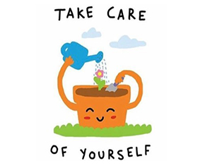

2020. Self-Care Toolkit COVID-19 Edition. [ebook] The University of Edinburgh, p.3. Available at:
<https://www.ed.ac.uk/news/covid-19/current-students/self-isolation/mental-health-and-wellbeing-support/self-care-toolkit> [Accessed 20 July 2021].
Take Care of Self
Plan
We all have different needs, strengths, and limitations. It is important to create a plan that is just right for you.

What are you doing to support your overall well-being on a day-to day basis? Do you engage in self-care practices now? Are you more active in some areas of self-care than others?
(To help you answer these questions refer to self-care assessment completed on pages 8 & 9).

Daily Self-Care

Physical (e.g. eat regular and healthy meals, good sleep habits, regular exercise, medical
check-ups, etc.)
Current Practices | Practices to Try

Emotional (e.g. engage in positive activities, acknowledge my own accomplishments,
express emotions in a healthy way etc.)
Current Practices | Practices to Try

Spiritual (e.g. read inspirational literature, self-reflection, spend time in nature, meditate,
explore spiritual connections, etc.)
Current Practices | Practices to Try

Professional (e.g. pursue meaningful work, maintain work-life balance, positive
relationships with co-workers, time management skills, etc.)
Current Practices | Practices to Try

Social (e.g. healthy relationships, make time for family/friends, schedule dates with
partner/spouse, ask for support from family and friends, etc.)
Current Practices | Practices to Try

Financial (e.g. understand how finances impact your quality of life, create a budget or
financial plan, pay off debt, etc.)
Current Practices | Practices to Try

Psychological (e.g. take time for yourself, disconnect from electronic devices, journal, pursue new interests, learn new skills, access psychotherapy, life coaching or counselling support if needed, etc.)
Current Practices | Practices to Try

What do you need in times of stress and distress? What do you need to avoid during those times?

Emergency Self-Care

Relaxation/Staying Calm
- Which activities help you to relax (e.g. deep breathing, taking a walk)?
- Which activities make you more agitated or frustrated (e.g. yelling, swearing, or drinking)?
Helpful (What To Do) | Harmful (What To Avoid)
Self-Talk
- Helpful self-talk may include, “I am safe/I can do this”.
- Harmful self-talk may include, “I can’t handle this/I knew this would happen/I deserve this”.
Helpful (What To Do) | Harmful (What To Avoid)

Social Support
- Which family members and friends can you reach out to for help or support?
- Which people should you avoid during times of stress? Be honest about who helps and who zaps your energy.
Helpful (What To Do) | Harmful (What To Avoid)

Mood
- Which activities support a positive mood (e.g. listening to uplifting music, enjoying the sunshine)?
- Which should you avoid when times get tough (e.g. staying in bed all day, avoiding social activities)?
Helpful (What To Do) | Harmful (What To Avoid)
Resilience
- What, or who, helps you get through difficult times? What helps you bounce back?
- What, or who, feeds negativity to you?
Helpful (What To Do) | Harmful (What To Avoid)

Are there any barriers or obstacles that are preventing you engaging in self-care? How can you address those barriers or obstacles?

Barriers | Ways to Address Barriers
Unable to leave work at work due to lesson planning, grading, and/or virtual learning | - Stay at work half an hour extra to plan or grade  - Scheduling time to plan or grade (make a family schedule and try as best as possible to stick to the times assigned; stop and return at a later time if needed)  - Setting alarms to limit time planning or grading (especially late at night, early morning, or when other activities or tasks need to be completed)
Barriers | Ways to Address Barriers

What is one commitment that you can make today to take better care of yourself?

n.d. Self-Care Starter Kit. [ebook] Homewood Health, Available at:
<https://employees.viu.ca/sites/default/files/homewood-self-care-starter-kit.pdf> [Accessed 20 July 2021].
Take Care of Self
Plan
Your self-care journey does not have to start with an elaborate plan. It can start with one step – focusing on today.

-  TODAY I FEEL | -  TODAY I WANT TO FEEL
-  HOW I WILL ACHIEVE THIS | MY GOALS FOR TODAY
-  TODAY’S AFFIRMATION | -  TODAY’S FOCUS
-  I CAN IMPROVE SLEEP BY | -  I CAN EAT HEALTHIER BY
-  I CAN EXERCISE BY | -  I CAN BE SOCIAL BY
-  I CAN BE SPIRITUAL BY | -  I CAN RELAX BY
-  I DID NOT LIKE IT WHEN | -  MY FAVORITE PART WAS

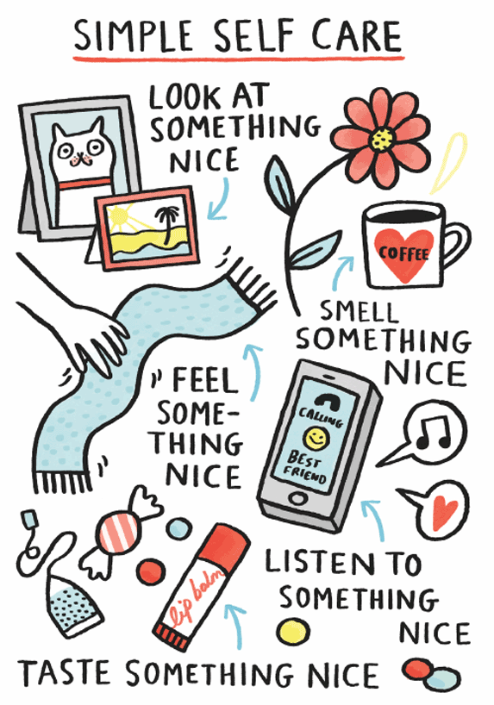

2020. Self-Care Toolkit COVID-19 Edition. [ebook] The University of Edinburgh, p.28 & 29. Available at:
<https://www.ed.ac.uk/news/covid-19/current-students/self-isolation/mental-health-and-wellbeing-support/self-care-toolkit> [Accessed 20 July 2021].
Take Care of Self
Plan
If creating a self-care plan seems overwhelming to you, try thinking about the things you would love to do and then think about how you can achieve these things.

-  I WOULD LOVE TO GO TO | -  I WOULD LOVE TO MAKE
-  I WOULD LOVE TO TRY | -  I WOULD LOVE TO READ
-  I WOULD LOVE  TO LET GO OF | -  I WOULD LOVE  TO LEARN
-  THINGS I AM  GRATEFUL FOR | -  THINGS  I ENJOY
-  THINGS THAT  MAKE ME HAPPY | -  THINGS THAT ARE IMPORTANT TO ME
-
THINGS THAT MAKE ME FEEL ACCOMPLISHED
-
THINGS THAT GIVE ME PURPOSE
-
THINGS I LIKE ABOUT MYSELF

2020. Self-Care Toolkit COVID-19 Edition. [ebook] The University of Edinburgh, p.30 - 32. Available at:
<https://www.ed.ac.uk/news/covid-19/current-students/self-isolation/mental-health-and-wellbeing-support/self-care-toolkit> [Accessed 20 July 2021].
Take Care of Self
Plan
By our nature, human beings are social beings. Thus, receiving support from others can replenish us, reduce our vulnerability to stress, and improve our health.

Do you have enough people in your social support network? Do the people in your network provide the quality of support you would like? Do you think anyone in your support network might be feeling overextended?

Social Support can be categorized into four types. List at least three people who provide each of the types of social support. It is OK to put the same person in more than one area. If there is an area that is lacking, try to come up with at least three ideas for ways to expand that area.

Emotional Support – demonstrations of empathy, love, caring, concern. Emotional support bolsters a person’s self-esteem and confidence. An emotional supporter serves as a confidante, offering acceptance, care, and understanding
People Who Provide This Support | Ways to Expand this Area of Support
Informational Support – assistance with knowledge, information, and skills. Can include providing information on where to go for resources or teaching a skill.
People Who Provide This Support | Ways to Expand this Area of Support

Instrumental Support – concrete assistance in helping others to do things or get things done, especially stressful or unpleasant tasks.
People Who Provide This Support | Ways to Expand this Area of Support

Companion Support – companionship, feeling connected, people in whose company you enjoy being, especially for recreational activities.
People Who Provide This Support | Ways to Expand this Area of Support

